**Main functionality**

1. **Register the provided services into the service registry.**

Objective and Decision: We need to test the first step for the initialization to register all the services. (Very important for the functionality of the system)

**Test Scenarios:**

* Structural Description: In the initialization process, the deployed systems are *ITSCentral, VehicleCamera, V2ICommunicator, RailwayProximitySensor and TimetableSensor.*
* Behavioral Description: No behavior description for the vehicles is considered.
* Successful registration of each system to its services into service registry for the local framework.
* Graphical representation:

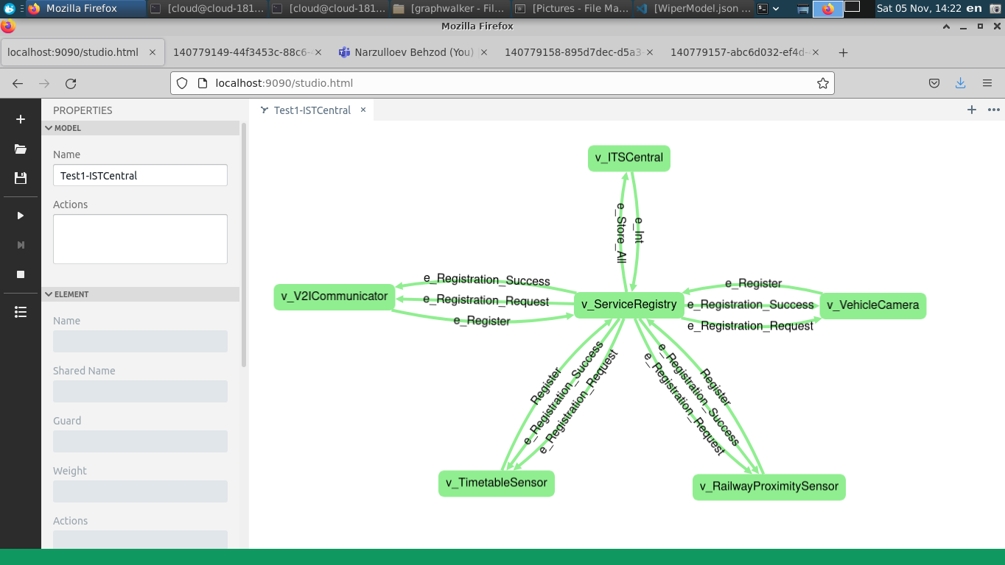

1. **Register the RailwayProximitySensor and TimetableSensor to ITSCentral.**

Objective and Decision: We need to test the registration of the sensors in the initialization process. (Very important for the functionality of the main components of the system)

**Test Scenarios:**

* Structural Description: In the initialization process, the deployed systems are *ITSCentral, VehicleCamera, V2ICommunicator, RailwayProximitySensor and TimetableSensor.*
* Behavioral Description:No behavior description for the vehicles is considered.

*RailwayProximitySensor* sends a register message to *ITSCentral.*

*ITSCentral* returns OK.

*TimetableSensor* sends a register message to *ITSCentral.*

*ITCentral* returns OK.

* Graphical representation:

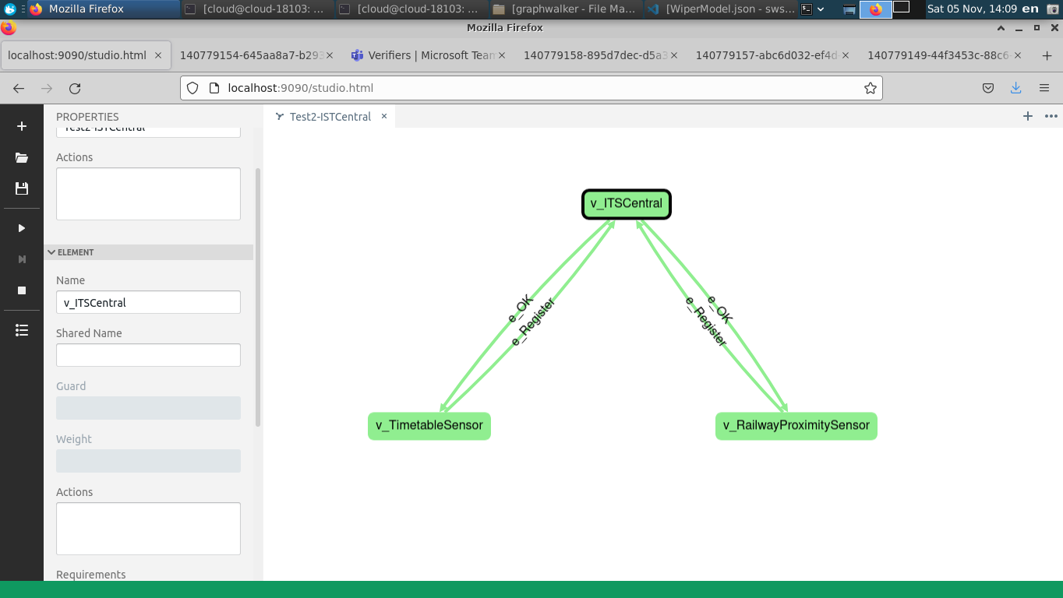

1. **Store the data for all the vehicles inside the intersection.**

Objective and Decision: We test if the system stores all vehicles inside the intersection. (Very important for the functionality of the system to make sure it sends a notification to the vehicles)

**Test Scenarios:**

* Structural Description: Deploy the following in the system *ITSCentral,* *V2ICommunicator and TimetableSensor,*
* Behavioral Description:

*TimetableSensor* sends a register message to *ITSCentral.*

*ITSCentral* sendsOK*.*

If four vehicles are heading to the intersections.

*V2ICommunicator* reports that there are four vechicles arriving to *ITSCentral* with their registration numbers.

*ITSCentral* stores the information and returnTRUEfor each vehicle*.*

* Graphical representation:

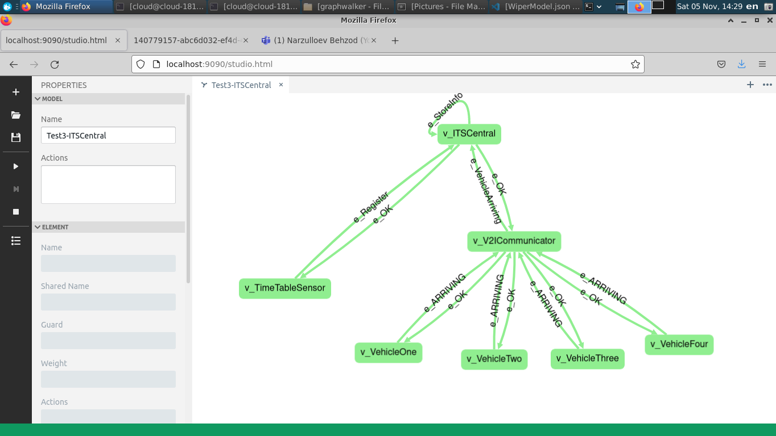

1. **Send a direct notifications to multiple vehicles**

Objective and Decision: Testing if system sends a notification to all the vehicles that has the data stored. (This is important to test different parts of the system are working properly and can handle multiple vehicles, it represents the main objective of the system which to alert vehicles when event arrives)

**Test Scenarios:**

* Structural Description: *ITSCentral, V2ICommunicator and ProximitySensor are* deployed in the system*.*
* Behavioral Description:

*ProximitySensor* sends a register message to *ITSCentral*

*ITSCentral* returns OK.

*V2ICommunicatorc* detects four vehicles it send an “Arriving” message with their registration number to *ITSCentral.*

*ITSCentral* stores the information of the vehicles and returns “True”

*ProximitySensor* detects if a train arrives and reports “Arriving” to *ITSCentral.*

*ITSCentral* returns OK.

*V2ICommunicator* sends a direct notification “Stop” to the vehicles.

The four vehicles receive notification “Stop”

* Graphical representation:

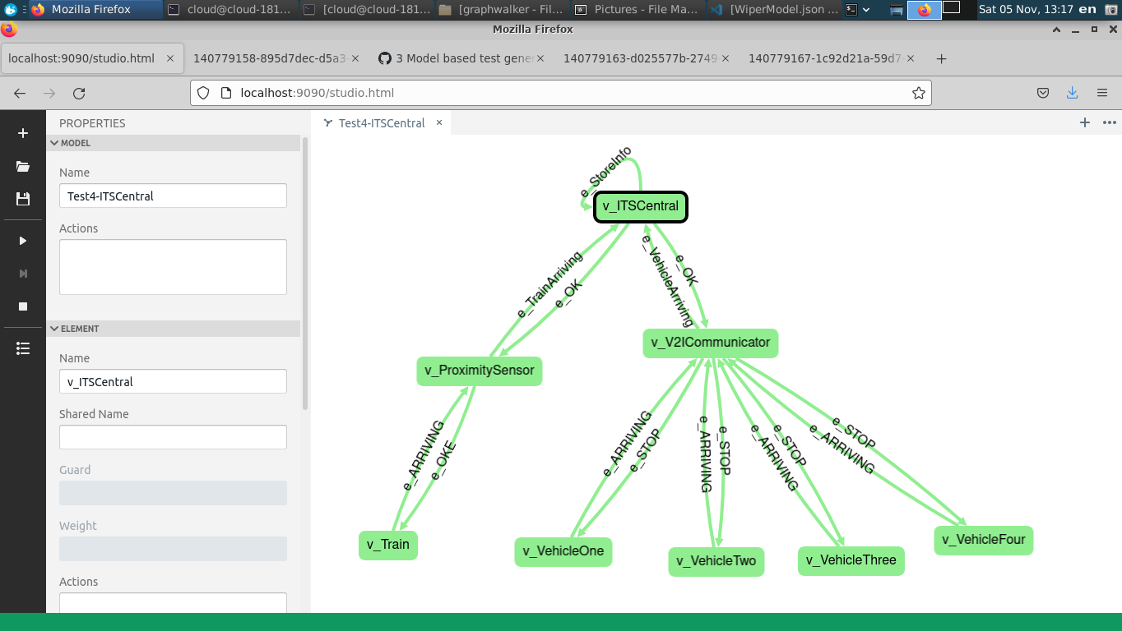

1. **Send a stop notification when train approaches.**

Objective and Decision: Test if a system sends a stop notification. (This is very important as the main objective of this system is to stop vehicles when train approaches)

**Test Scenarios:**

* Structural Description: *ITSCentral, V2ICommunicator, RailwayProximitySensor* are deployed.
* Behavioral Description:

*RailwayProximitySensor* sends a register message to *ITSCentral*

*ITSCentral* returns OK

A vehicle arrives to intersection

*V2ICommunicator* reports the vehicle is “Arriving” with its registration to *ITSCentral.*

*RailwayProximitySensor* detects if a train is approaching and reports “Arriving” to *ITSCentral.*

*ITSCentral* returns OK

*V2ICommunicator* sends a “Stop” notification to the vehicle.

The vehicle receives “Stop”.

* Graphical representation

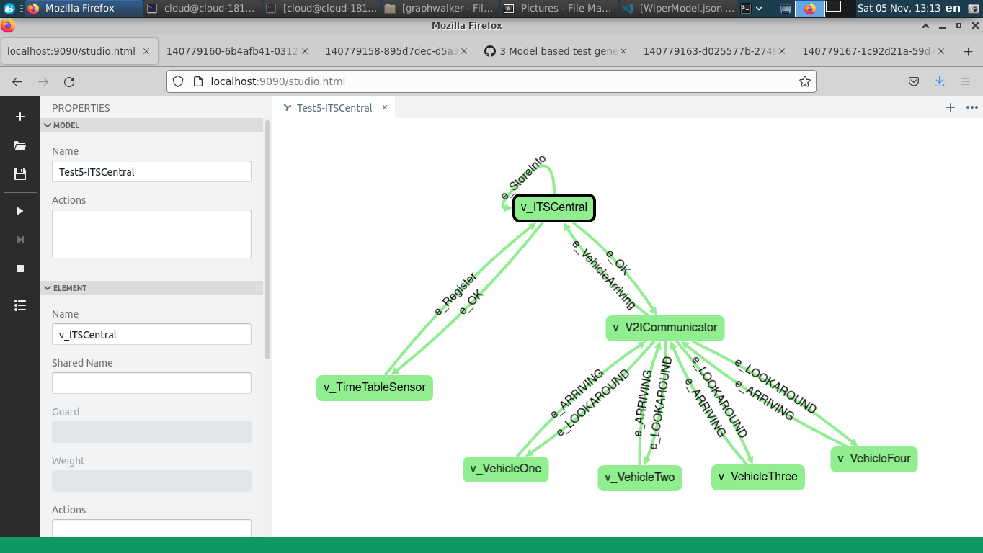

1. **Send TrainMightArrive notification if a train passes the intersection according to the timetable.**

Objective and Decision: Test if the system sends TrainMightArrive notification. (This is very important where TimetableSensor is deployed)

**Test Scenarios:**

* Structural Description: *ITSCentral, V2ICommunicator and TimetableSensor* are deployed.
* Behavioral Description

*TimetableSensor* sends Register message *to ITSCentral.*

*ITSCentral* returns OK.

If a vehicle arrives to intersection.

*V2ICommunicator* reports vehicle is “Arriving” with their registration number to *ITSCentral.*

TimetableSensor detects if train arrives and reports “Arriving” to *ITSCentral.*

*ITSCentral* returns OK

*V2ICommunicator* sends “TrainMightArrive” to vehicle.

The vehicle receives “TrainMightArrive”

* Graphical representation:

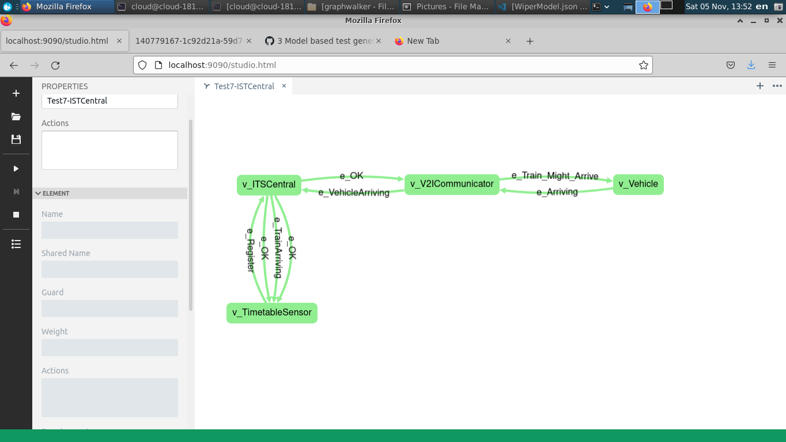

**Special Cases**

1. **Sensors sends an event before registration**

Objective and Decision: Test if sensors send events before registering to *ITSCentral.* (Its very important when the sensor don’t send events before registration)

**Test Scenarios:**

* Structural Description *ITSCentral, V2ICommunicator and TimetableSensor* are deployed in the system.
* Behavioral Description

*TimetableSensor* detects if train arrives and reports “Arriving” to *ITSCentral.*

*ITSCentral* don’t send OK because the sensor is not registered.

*TimetableSensor* sends register to *ITSCentral.*

*ITSCentral* returns OK.

* Graphical representation:

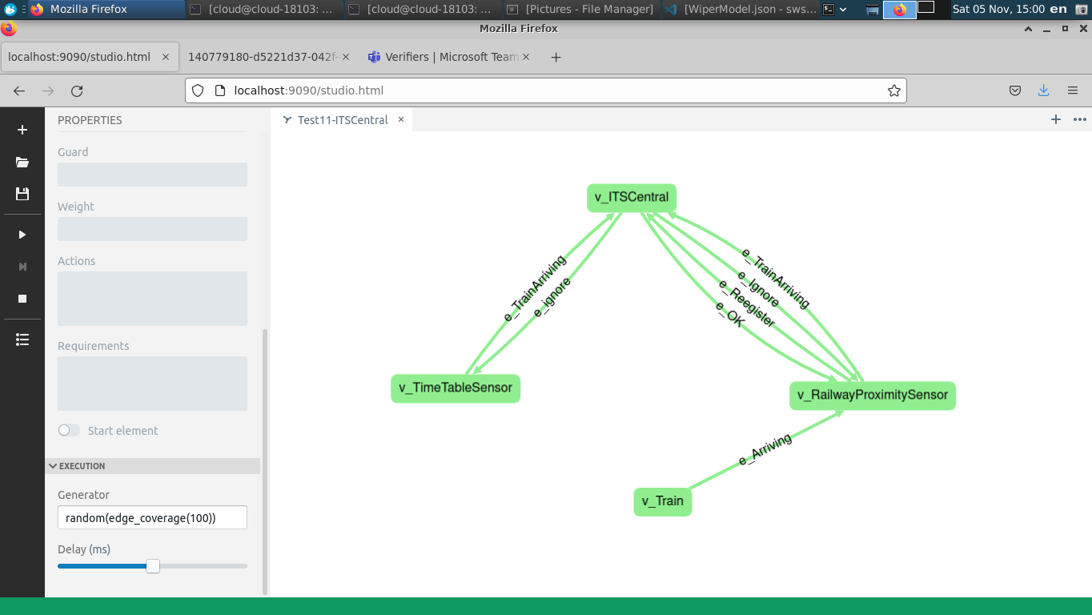

1. **Ignore a register message from the sensor if it already received another register message from another sensor.**

Objective and Decision: Test if the system ignores registration of the sensor. (This is very important so the system don’t register multiple times so it doesn’t register multiple events to central system)

**Test Scenarios:**

* Structural Description: *ITSCentral, V2ICommunicator, and RailwayProximitySensor* are deployed in the system.
* Behavioral Description

*RailwayProximitySensor* sends Register to *ITSCentral.*

*ITSCentral* returns OK.

*RailwayProximitySensor sends Register to ITSCentral*

*ITSCentral* don’t return OK, because the sensor already has been registered.

* Graphical representation:

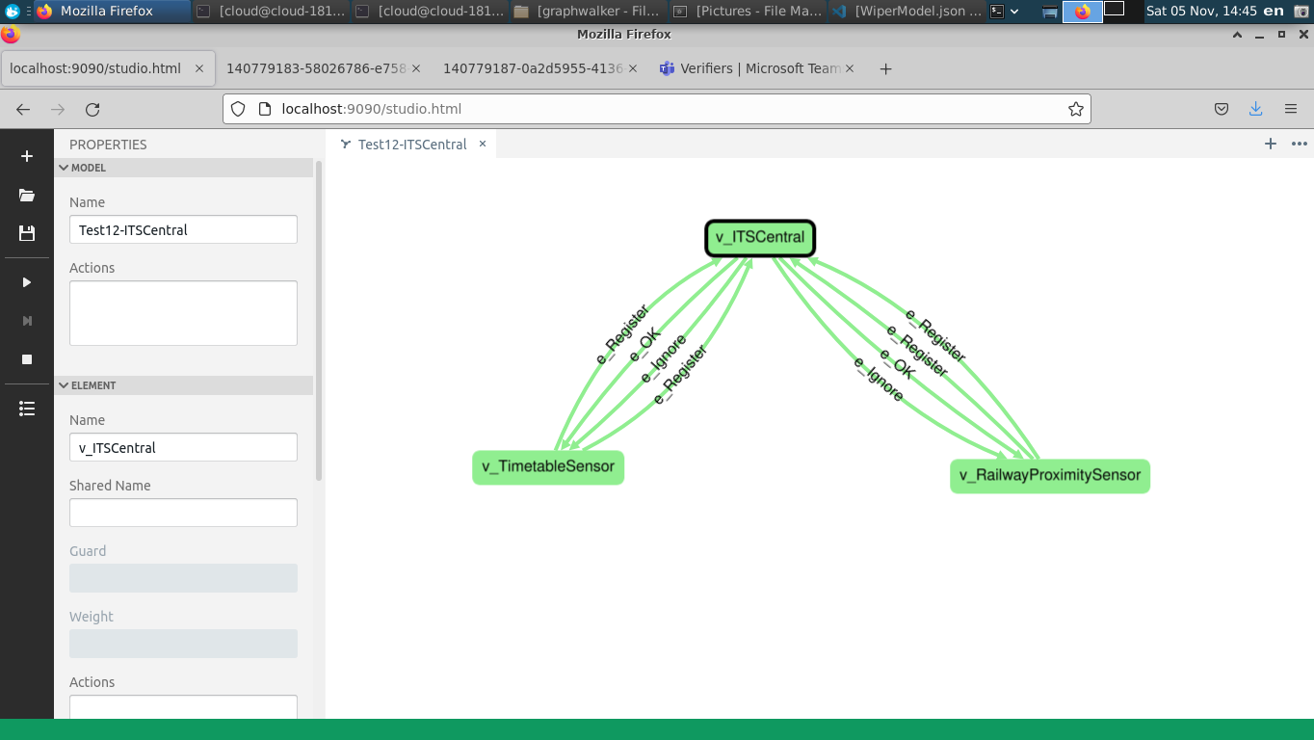

1. **Return False if the reported vehicle is already stored.**

Objective and Decision: Tests if the system registered a vehicle or not. (This is very important so the system don’t duplicate the registration of vehicles or send notification more than one time)

**Test Scenarios:**

* Structural Description: *ITSCentral, V2ICommunicator and TimetableSensor.*
* Behavioral Description

*TimetableSensor* sends Register to *ITSCentral.*

*ITSCentral* return Ok.

When Vehicle approaches an intersection.

*V2ICommunicator* detects if vehicle arrives and reports “Arriving” and its registration number to *ITSCentral*

*ITSCentral* stores the information and returns “True”

*V2ICommunicator* detects and reports the same vehicle again.

*ITSCentral* returns False and don’t register it again.

* Graphical representation:

